CS 506 homework 1

Due: Beginning of week 2

1.

How much more inaccurate is binary integer arithmetic than decimal integer arithmetic? Can the accuracy of

binary computers be improved to make them as accurate as decimal computers?

Representing fractional numbers arises inaccuracies. not all fractional number can be represented with acurate finite number bits. Inaccuracy can not be exactly calculated due to same

2.

What are the decimal equivalents of the following values (assume positional notation and unsigned integer

formats):

a. 110011002 = 204

b. 110011003 =2954

c. 110011004 = 20560

d. 11001100‐2 = -68

3.

Convert the following decimal numbers into (a) binary and (b) hexadecimal forms

a. 25 = bi (11001) hexa(19)

b. 250 = bi (11111010) hexa(FA)

c. 2500 = bi(100111000100) hexa (9C4)

d. 25555 = bi(110001111010011) hexa(63D3)

4.

Perform the following calculations in the stated bases

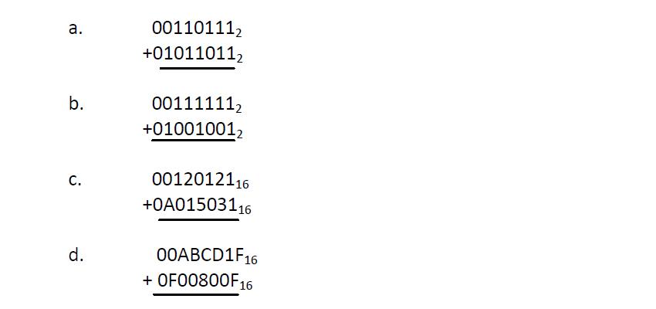

a) 010010010

b) 010001000

c) A135152

d) FAC4D2E

5.

Positive and negative numbers can be represented in many ways in a computer. List some of the ways of

representing signed numbers. Can you think of any other ways of representing signed values?

Ones complement

Twos complement

Excess notation

Signed bit representation-